namespace NoughtsCrossesModel

{

public interface IGame

{

public char WhatsAt(int row, int column);

public void AddMark(int row, int column, char mark);

public int Width();

public int Height();

public int Turn();

}

}

using System;

using System.Collections.Generic;

using System.Reflection.Metadata.Ecma335;

using System.Text;

namespace NoughtsCrossesModel

{

public class Game : IGame

{

char[,] board = new[,] { { ' ', ' ', ' ' }, { ' ', ' ', ' ' }, { ' ', ' ', ' ' } };

int turn = 0;

public char WhatsAt(int row, int column)

{

return board[row, column];

}

public void AddMark(int row, int column, char mark)

{

board[row, column] = mark;

turn++;

}

public int Width() { return 3; }

public int Height() {return 3; }

override public string ToString()

{

String result = $"turn:{turn}\n";

result += " | | \n";

result += $" {board[0, 0]} | {board[0, 1]} | {board[0, 2]} \n";

result += "_____|_____|_____\n";

result += " | | \n";

result += $" {board[1, 0]} | {board[1, 1]} | {board[1, 2]} \n";

result += "_____|_____|_____\n";

result += " | | \n";

result += $" {board[2, 0]} | {board[2, 1]} | {board[2, 2]} \n";

result += " | | \n\n";

return result;

}

int IGame.Turn()

{

return turn;

}

}

}

using NoughtsCrossesModel;

namespace NoughtsAndCrosses

{

internal class Controller

{

IGame game;

public Controller(IGame newGame)

{

game = newGame;

}

public void AddMark(int row, int column, char mark)

{

game.AddMark(row, column, mark);

}

public int Height()

{

return game.Height();

}

public int Turn()

{

return game.Turn();

}

public string WhatsAt(int row, int column)

{

return game.WhatsAt(row, column).ToString();

}

public int Width()

{

return game.Width();

}

}

}

private void Form1_Load(object sender, EventArgs e)

{

controller = new Controller(new Game());

}

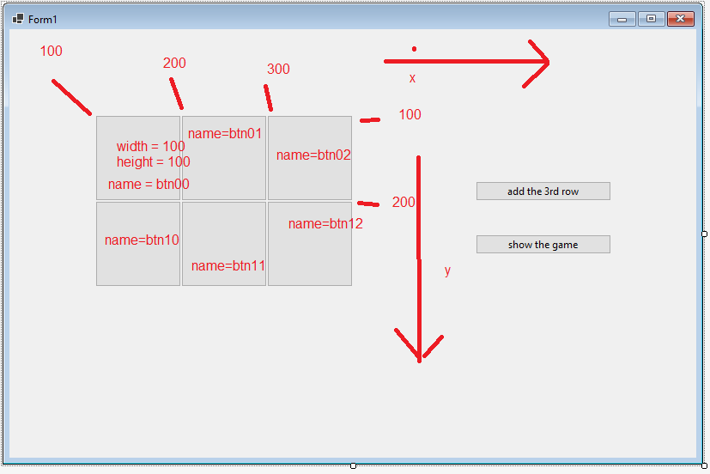

namespace NoughtsAndCrosses

{

partial class Form1

{

/// <summary>

/// Required designer variable.

/// </summary>

private System.ComponentModel.IContainer components = null;

/// <summary>

/// Clean up any resources being used.

/// </summary>

/// <param name="disposing">true if managed resources should be disposed; otherwise, false.</param>

protected override void Dispose(bool disposing)

{

if (disposing && (components != null))

{

components.Dispose();

}

base.Dispose(disposing);

}

#region Windows Form Designer generated code

/// <summary>

/// Required method for Designer support - do not modify

/// the contents of this method with the code editor.

/// </summary>

private void InitializeComponent()

{

this.btn00 = new System.Windows.Forms.Button();

this.btn01 = new System.Windows.Forms.Button();

this.btn02 = new System.Windows.Forms.Button();

this.btn10 = new System.Windows.Forms.Button();

this.btn11 = new System.Windows.Forms.Button();

this.btn12 = new System.Windows.Forms.Button();

this.button1 = new System.Windows.Forms.Button();

this.button2 = new System.Windows.Forms.Button();

this.SuspendLayout();

//

// btn00

//

this.btn00.Location = new System.Drawing.Point(100, 100);

this.btn00.Name = "btn00";

this.btn00.Size = new System.Drawing.Size(100, 100);

this.btn00.TabIndex = 0;

this.btn00.Text = "\r\n\r\n";

this.btn00.UseVisualStyleBackColor = true;

//

// btn01

//

this.btn01.Location = new System.Drawing.Point(200, 100);

this.btn01.Name = "btn01";

this.btn01.Size = new System.Drawing.Size(100, 100);

this.btn01.TabIndex = 0;

this.btn01.Text = "\r\n\r\n";

this.btn01.UseVisualStyleBackColor = true;

//

// btn02

//

this.btn02.Location = new System.Drawing.Point(300, 100);

this.btn02.Name = "btn02";

this.btn02.Size = new System.Drawing.Size(100, 100);

this.btn02.TabIndex = 0;

this.btn02.Text = "\r\n\r\n";

this.btn02.UseVisualStyleBackColor = true;

//

// btn10

//

this.btn10.Location = new System.Drawing.Point(100, 200);

this.btn10.Name = "btn10";

this.btn10.Size = new System.Drawing.Size(100, 100);

this.btn10.TabIndex = 0;

this.btn10.Text = "\r\n\r\n";

this.btn10.UseVisualStyleBackColor = true;

//

// btn11

//

this.btn11.Location = new System.Drawing.Point(200, 200);

this.btn11.Name = "btn11";

this.btn11.Size = new System.Drawing.Size(100, 100);

this.btn11.TabIndex = 0;

this.btn11.Text = "\r\n\r\n";

this.btn11.UseVisualStyleBackColor = true;

//

// btn12

//

this.btn12.Location = new System.Drawing.Point(300, 200);

this.btn12.Name = "btn12";

this.btn12.Size = new System.Drawing.Size(100, 100);

this.btn12.TabIndex = 0;

this.btn12.Text = "\r\n\r\n";

this.btn12.UseVisualStyleBackColor = true;

//

// button1

//

this.button1.Location = new System.Drawing.Point(543, 239);

this.button1.Name = "button1";

this.button1.Size = new System.Drawing.Size(158, 23);

this.button1.TabIndex = 1;

this.button1.Text = "show the game";

this.button1.UseVisualStyleBackColor = true;

this.button1.Click += new System.EventHandler(this.button1_Click_1);

//

// button2

//

this.button2.Location = new System.Drawing.Point(543, 177);

this.button2.Name = "button2";

this.button2.Size = new System.Drawing.Size(158, 23);

this.button2.TabIndex = 2;

this.button2.Text = "add the 3rd row";

this.button2.UseVisualStyleBackColor = true;

this.button2.Click += new System.EventHandler(this.button2_Click);

//

// Form1

//

this.AutoScaleDimensions = new System.Drawing.SizeF(7F, 15F);

this.AutoScaleMode = System.Windows.Forms.AutoScaleMode.Font;

this.ClientSize = new System.Drawing.Size(800, 499);

this.Controls.Add(this.button2);

this.Controls.Add(this.button1);

this.Controls.Add(this.btn12);

this.Controls.Add(this.btn11);

this.Controls.Add(this.btn10);

this.Controls.Add(this.btn02);

this.Controls.Add(this.btn01);

this.Controls.Add(this.btn00);

this.Name = "Form1";

this.Text = "Form1";

this.Load += new System.EventHandler(this.Form1_Load);

this.Paint += new System.Windows.Forms.PaintEventHandler(this.Form1_Paint);

this.ResumeLayout(false);

}

#endregion

private System.Windows.Forms.Button btn00;

private System.Windows.Forms.Button btn01;

private System.Windows.Forms.Button btn02;

private System.Windows.Forms.Button btn10;

private System.Windows.Forms.Button btn11;

private System.Windows.Forms.Button btn12;

private System.Windows.Forms.Button button1;

private System.Windows.Forms.Button button2;

}

}

using System;

using System.Drawing;

using System.Windows.Forms;

using NoughtsCrossesModel;

namespace NoughtsAndCrosses

{

public partial class Form1 : Form

{

Controller controller;

public Form1()

{

InitializeComponent();

}

private void makeButtons()

{

for (int column = 0; column <= 2; column++)

{

Button newBtn = new Button();

newBtn.Name = $"btn2{column}";

newBtn.Location = new System.Drawing.Point(100 * (column+1), 300);

newBtn.Size = new System.Drawing.Size(100, 100);

newBtn.Text = "Z";

this.Controls.Add(newBtn);

}

}

private void button2_Click(object sender, EventArgs e)

{

makeButtons();

}

private void button1_Click_1(object sender, EventArgs e)

{

controller.AddMark(0, 0, 'O');

controller.AddMark(0, 2, 'X');

controller.AddMark(2, 0, 'O');

controller.AddMark(1, 0, 'X');

controller.AddMark(2, 2, 'O');

controller.AddMark(2, 0, 'X');

for (int row =0; row<=2; row++)

{

for (int column=0; column<=2; column++)

{

string toShow = controller.WhatsAt(row, column);

string btnName = $"btn{row}{column}";

Control[] btns = Controls.Find(btnName, true);

btns[0].Text = toShow;//.ToString();

}

}

}

private void Form1_Paint(object sender, PaintEventArgs e)

{

Pen pen = new Pen(Color.FromArgb(255, 0, 0, 0));

e.Graphics.DrawLine(pen, 90, 200, 410, 200);

e.Graphics.DrawLine(pen, 90, 300, 410, 300);

e.Graphics.DrawLine(pen, 200, 100-10, 200, 400+10);

e.Graphics.DrawLine(pen, 300, 100 - 10, 300, 400 + 10);

}

}

}